Two-Step Turning Process
I am an advocate of a two-step turning process. I use my gouges to shape my platters and bowls, removing 99% of the wood. But before sanding, I scrape the entire surface of the woodturning. I consider scraping the first step in sanding, but the scraper is far more accurate and delicate than sandpaper, getting the surface of the woodturning “perfect” before sanding begins.
Many woodturners think any woodturner who scrapes his/her work is a poor woodturner. I believe any woodturner who sands too much is a poor woodturner. A negative-rake scraper, in the hands of a skilled woodturner, is far more accurate than sandpaper. Sandpaper never improves a woodturning. Never! Sanding may get it smoother, but never better. Careful negative-rake scraping will improve the woodturning and reduce the amount of sanding required.
I advocate the use of negative-rake scrapers. The cutting edge of my negative-rake scrapers is ground at 22.5 degrees top and bottom, so the nose of the scraper has an included angle of 45 degrees. The scraper is held flat (horizontally) on the tool rest and is therefore exceptionally easy to control. The negative rake on the top of the grind, and the fact that the scraper is held level (horizontally) on the tool rest, means the scraper does not self-feed, will not “catch”, and is therefore exceedingly easy to control. The burr on a negative-rake scraper is the only thing which cuts smoothly, so the scraper must be sharpened (reground) frequently to refresh the burr. In use, the scraper is held “burr up”, and the cutting edge is ever-so-gently floated across the surface of the wood, removing every ripple, dimple, and every speck of tear-out, even on difficult, highly figured hardwoods. If the scraper must be pushed into the wood to get it to cut, it is dull and will do more harm than good. Very delicate scraping with the burr of a freshly sharpened scraper is the correct technique for excellent results.
Conventional wisdom says a scraper must be big and heavy to dampen vibration, and should be held “nose-down” to avoid catches. Because the nose of a negative-rake scraper is already ground “down”, the scraper can be held flat (horizontally) on the tool rest, and will not self-feed or catch. A negative-rake scraper does not need to be heavy. Since a very light touch works better, I prefer a light-weight scraper. And the harder the metal, the longer it will stay sharp. I prefer CPM 10V scrapers, ground on a 180 grit CBN wheel.
If examined under a microscope, the cutting edge of a freshly sharpened negative-rake scraper looks like very fine sandpaper, and it works like sandpaper, except that it can be used with much greater accuracy and delicacy, perfectly preparing the surface before sanding commences. It’s exceptionally easy to remove all irregularities, fine tune curves, and get that ”perfect” shape. If the turning isn’t “perfect” before sanding, sanding will not improve it. Get it right with the two-step turning process before sanding. You will be impressed with the results!

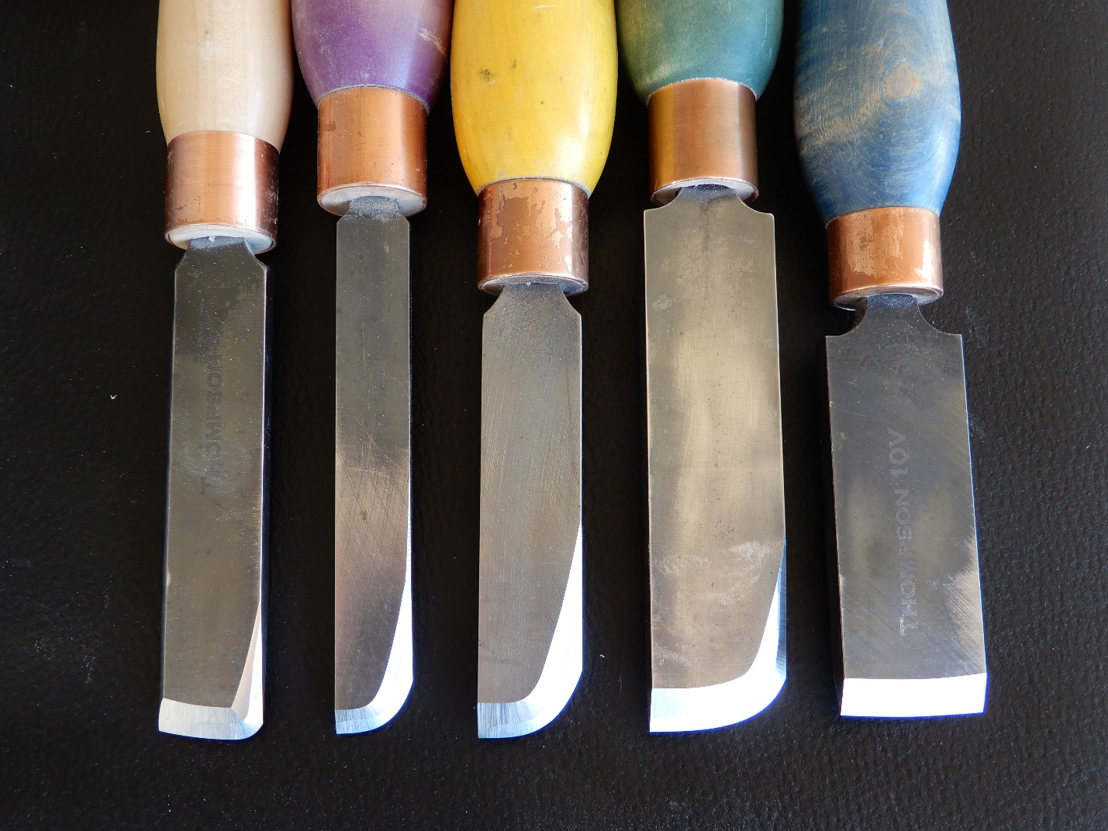

Above is a photo of some of my negative-rake scrapers. The scrapers are ground at 22.5 degrees top and bottom, so the cutting edge is symmetrical, allowing the scrapers to be used with either side up. The cutting edge is ground to closely match the curve of the surface it will be scraping. When the scraper is ground, the 180 grit CBN grinding wheel forms a burr along the cutting edge. The tool is always addressed to the wood “burr up”. A sharp burr smoothes the wood, refining curves and removing every vestige of tearout, significantly reducing sanding. The scraper must be kept very sharp. The burr wears away quickly, necessitating frequent regrinding. Even though frequent regrinding is necessary to keep the scraper cutting effectively, it is far quicker and easier to smooth wood with a negative-rake scraper than with sandpaper, and the results are far superior.
Tom Wirsing, Thomas Wirsing Woodturning, 2023

